**Middleware of Technical Diagram:**

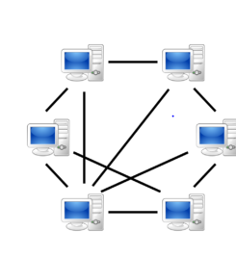



P2P Network

**Overview of Technical Diagram:**



**Technical Architectural Diagram:**



Our system contains a mobile app and a web app, and their total processing is made more efficient by a load balancer, which divides incoming network traffic across a cluster of three dispersed servers.

**Load Balancing:**

**System architectural Diagram:**



**Time Line:**

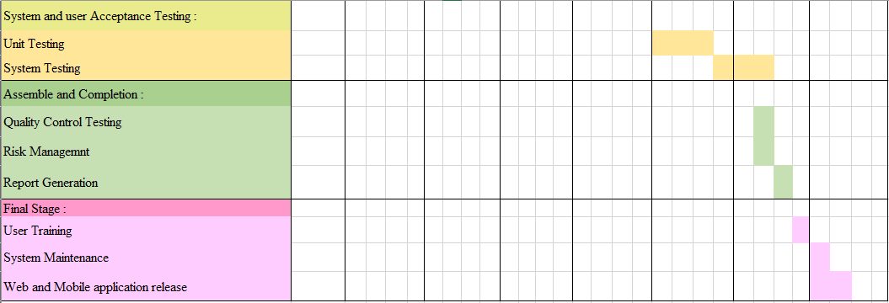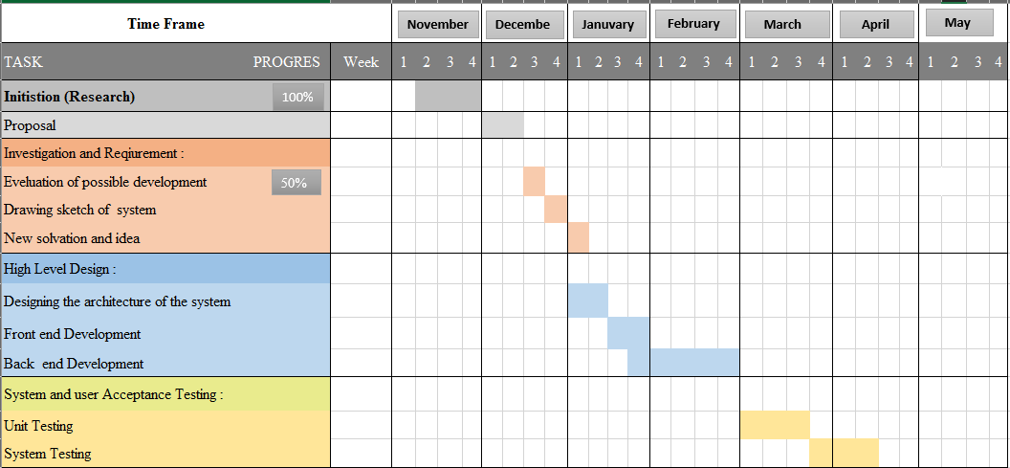

**Development phases:**

|  |  |
| --- | --- |
| Development phases | Description |
| 1. Planning | Defining the project's boundaries in terms of how large the scope will be. Creating a project plan, calculating how long it will take to finish the work, and breaking it down into pieces, or sequencing the work, and creating an initial project schedule |
| 2. Analysis | Analyzing the system's critical features and requirements to determine whether it is worthwhile to develop. |
| 3. Designing | Designing aids in determining the shape of what should be constructed. It functions as a template for how the implementation should proceed. Includes thorough software architecture, database, and frontend designs**.** |
| 4. Coding and debugging | This includes database development, website creation, and the implementation and development of backend logic, as well as frontend development. In the same way, a mobile application with implemented logic and a frontend is generated. In addition, an API to interface with the MySQL database has been developed. |
| 5. Testing | Functional testing is done to determine if we are obtaining the expected outcomes. Every unit of code in our project was tested as part of the unit testing process. Integration Testing was conducted after the system's modules were integrated to determine if they worked together. The complete system was then put through End-to-End testing. User Interface Testing, which entails testing the application's user interface, was carried out to see if the UIs were designed in accordance with the system's specifications. Load Testing was conducted as part of non-functional testing to enhance the system's quality. It checked the system's capacity to take load. |
| 6. Deliver the product | Deliver the website, mobile application and report**.** |

**System Diagram:**



**Context Diagram:**



**User Case:**



Slideshare.net. 2022. *Weather Now*. [Online] Available at: <https://www.slideshare.net/AmilaWijayarathna/weather-now-75943627> [Accessed 8 May 2022].